# Analysis of Canadian Dinner Trends

**1. Introduction and Objective**

This report delves into Canadian dinner trends, focusing on how meal preferences vary across demographics like age, income, and region. The goal is to analyze trends in dining habits, including meal types (e.g., restaurant, takeout, home-cooked), cuisine preferences, and expenditure patterns. The insights from this report will help businesses in the food industry better understand consumer behavior.

**2. Data Collection and Source Information**

The dataset was collected through surveys capturing Canadian dining habits. It includes information on meal preferences, expenditure on dinner, and popular cuisines. The data is segmented by age group, income level, and region, allowing for a granular analysis of how these factors influence dining preferences. This data is especially useful for restaurants, food delivery companies, and marketers to develop targeted strategies.

**3. Dataset Structure and Column Descriptions**

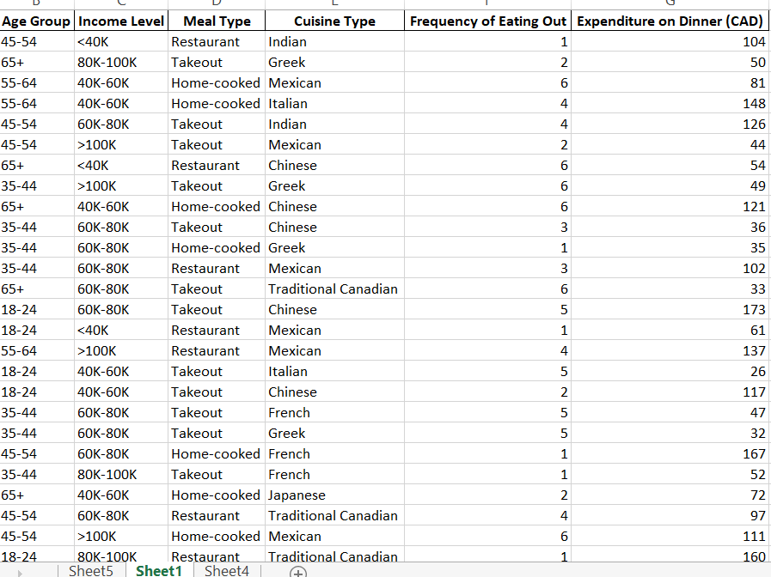

The dataset comprises several key columns:

* **Region**: Categorical data indicating Canadian provinces.
* **Age Group**: Categorical grouping of individuals by age (e.g., 18-24, 45-54, 65+).
* **Income Level**: Income categories such as <40K, 40K-60K, 60K-80K, >100K.
* **Meal Type**: This column categorizes meals as Restaurant, Takeout, or Home-cooked.
* **Cuisine Type**: Represents the cuisine preferences such as Mexican, Indian, Italian, etc.
* **Frequency of Eating Out**: Numerical data showing how many times an individual eats out per week.
* **Expenditure on Dinner (CAD)**: The amount spent on dinner per person in Canadian dollars.

**4. Data Cleaning and Preprocessing**

The dataset was cleaned and preprocessed using Excel before analysis:

* **Duplicate Removal**: Excel was used to remove duplicate entries to ensure that each record in the dataset was unique.

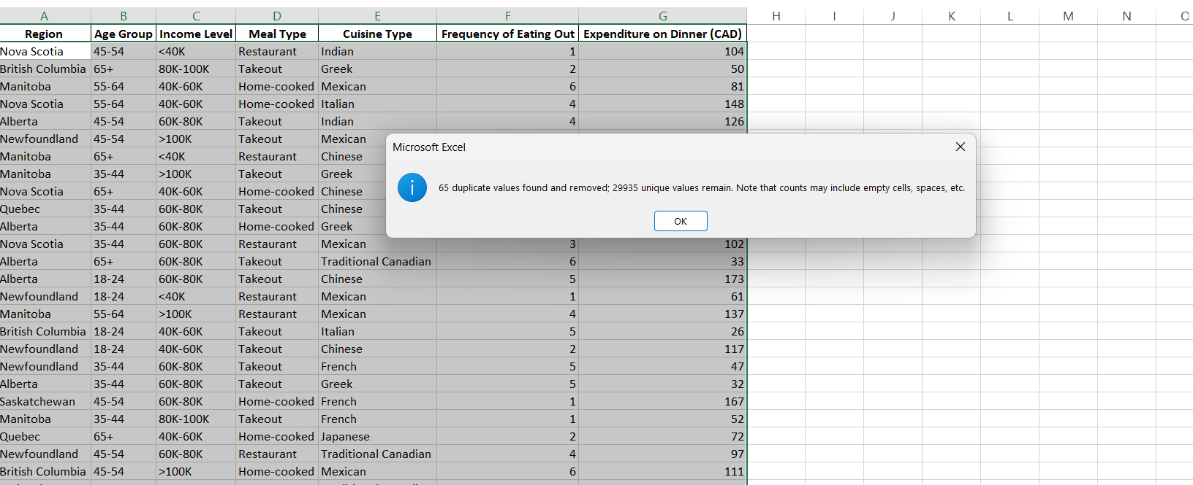

* **Missing Data**: Missing values in key columns were either filled using imputation or removed if too significant.

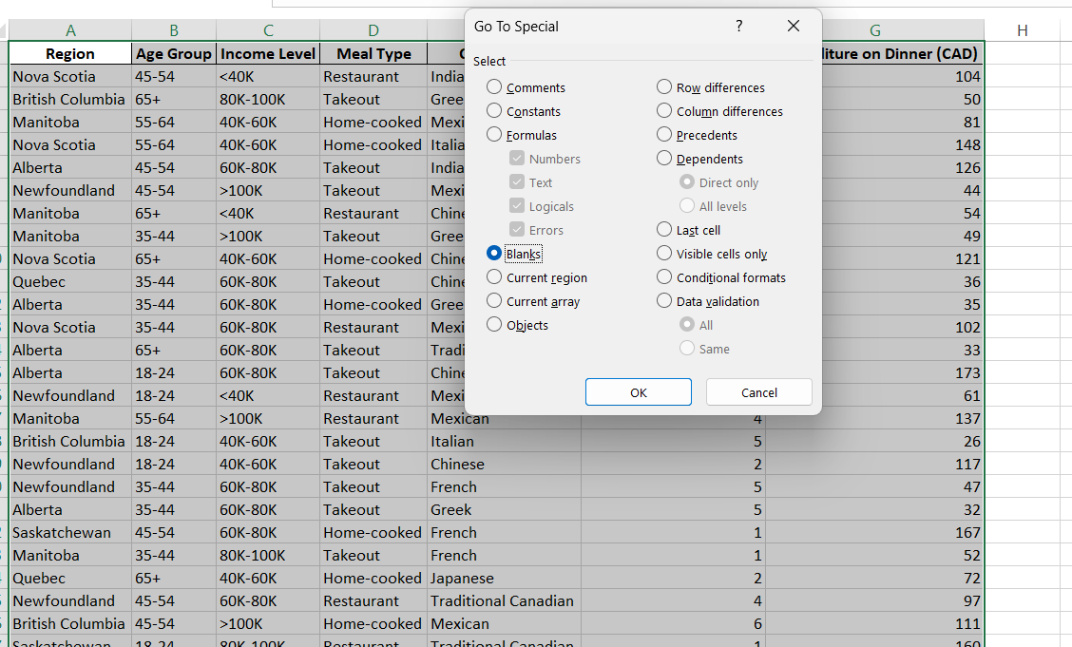

* **Outlier Handling**: Outliers in expenditure data were capped or removed to prevent them from skewing the analysis.

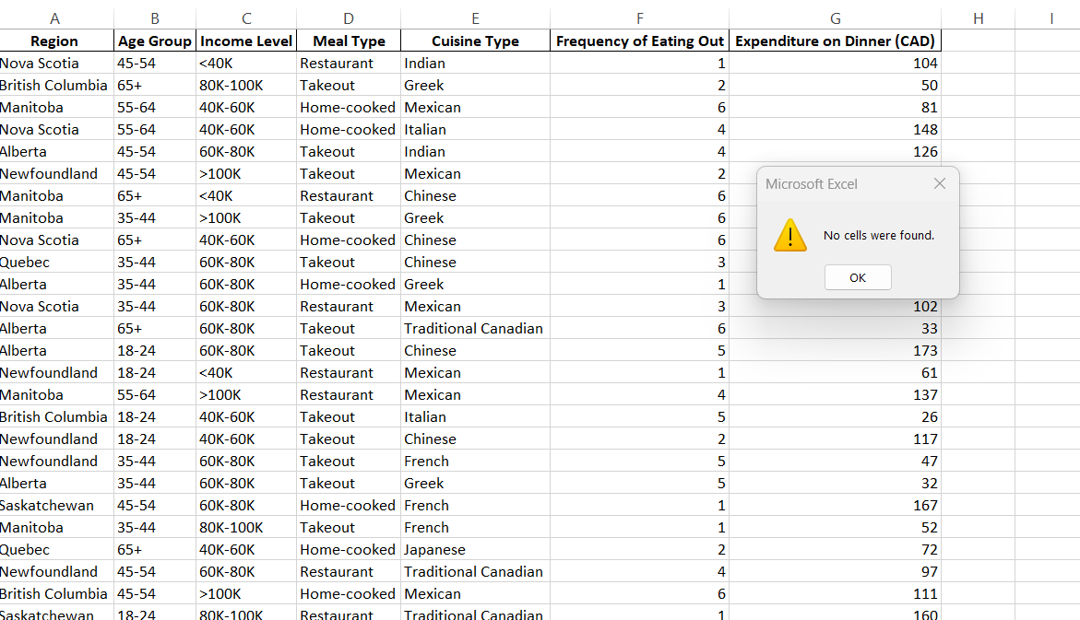

* **Categorical Encoding**: Categorical data such as "Cuisine Type" and "Meal Type" was encoded to enable deeper analysis.

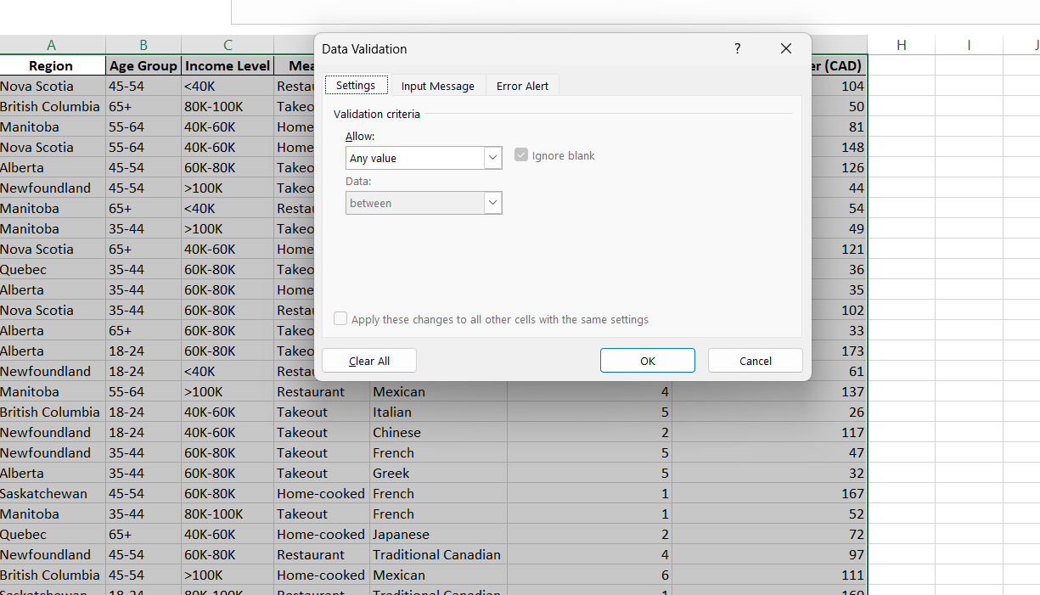

**5. Analysis of Trends and Findings**

* **Meal Type Preferences**: Younger age groups (18-24) had a strong preference for takeout, while older groups (55-64) leaned towards home-cooked meals. Individuals in the higher-income bracket (>100K) were more inclined to eat at restaurants.
* **Most Preferred and Least Preferred Meal Type**:
  + **Most Preferred**: **Takeout** was the most popular meal type, especially among younger and middle-income individuals.
  + **Least Preferred**: **Home-cooked meals** were least popular among younger age groups, though they were favored by older groups.
* **Cuisine Preferences**:
  + **Most Preferred Cuisine**: **Mexican cuisine** emerged as the most favored, particularly for takeout.
  + **Least Preferred Cuisine**: **Italian cuisine** was the least preferred cuisine type, with less popularity across different meal types.
* **Expenditure Analysis**: Higher-income individuals, particularly those earning over 100K, not only dined out more frequently but also spent significantly more per meal compared to other income groups.
* **Regional Trends**: Different provinces showed varying dining preferences. For instance, British Columbia residents favored Greek cuisine, while Indian cuisine was a popular choice in Nova Scotia.

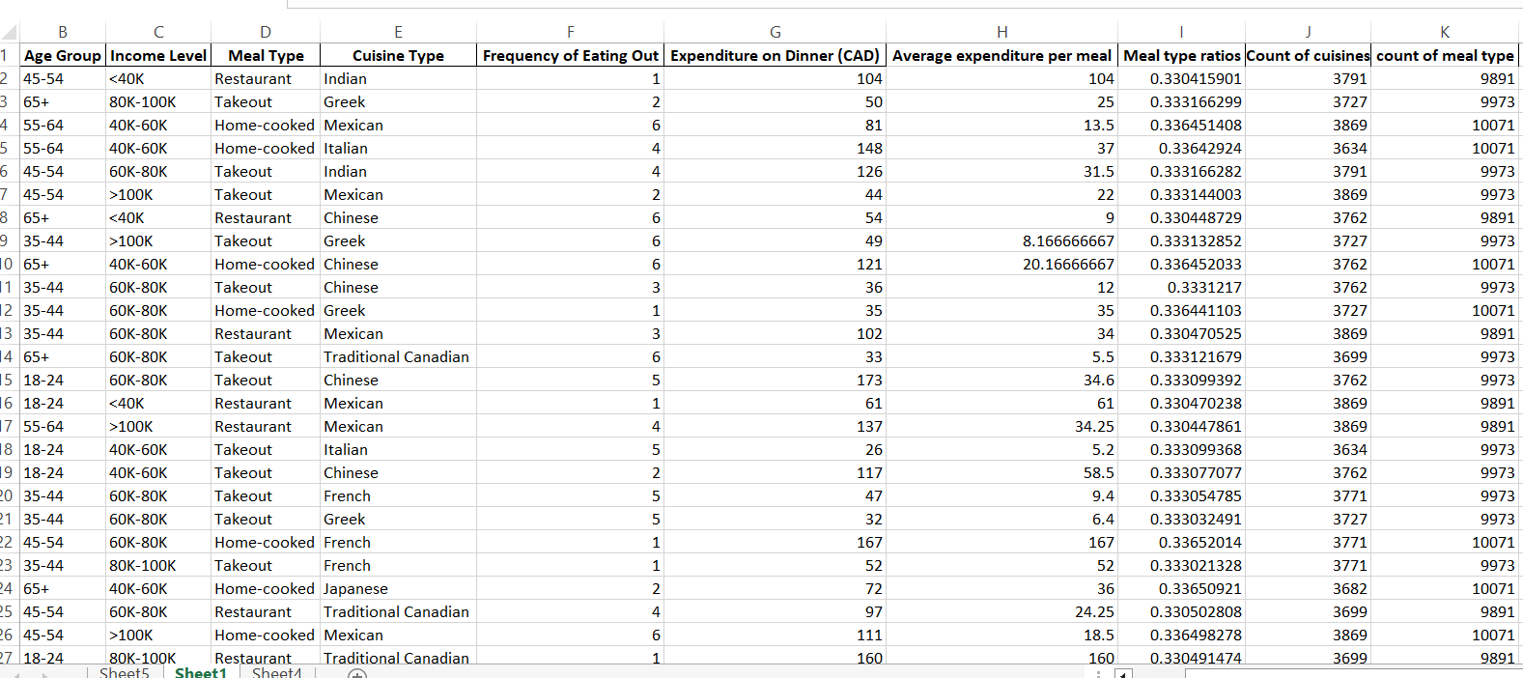

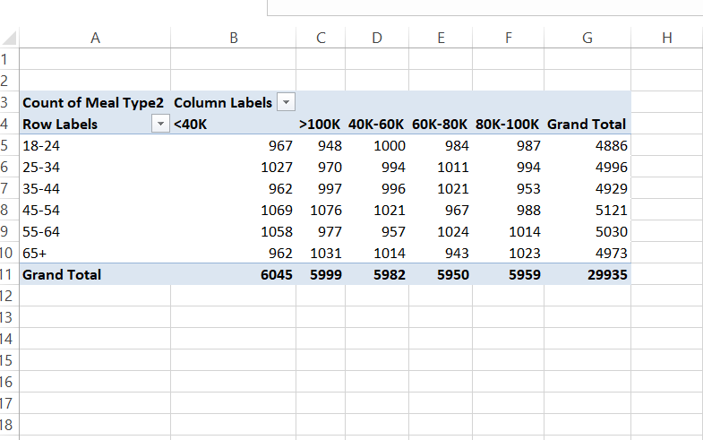

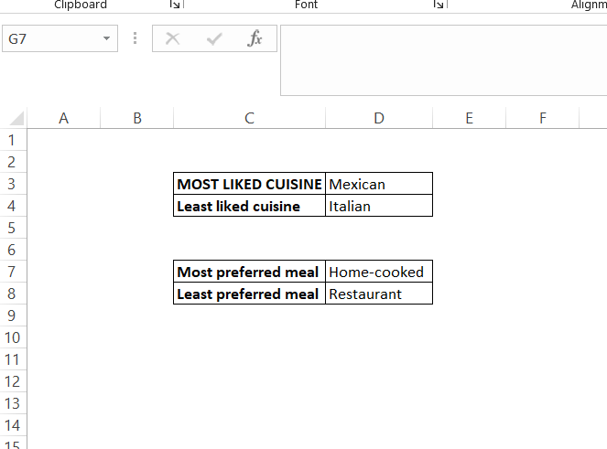

**6. Visualizations Used**

The visualizations were created using **Power BI** to effectively communicate the trends and findings:

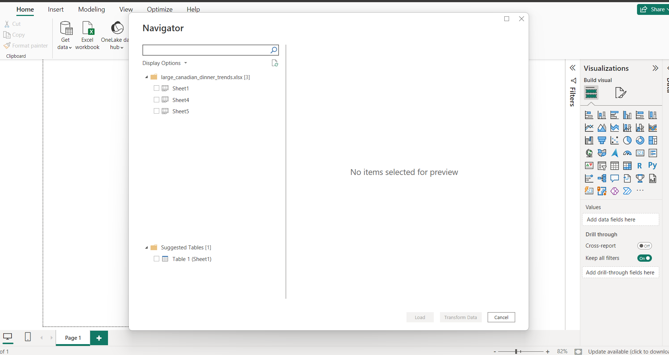

* **Bar Charts**: Bar charts were employed to compare meal preferences across different age groups and income levels. For example, a bar chart highlighted that individuals aged 18-24 had a higher preference for takeout.

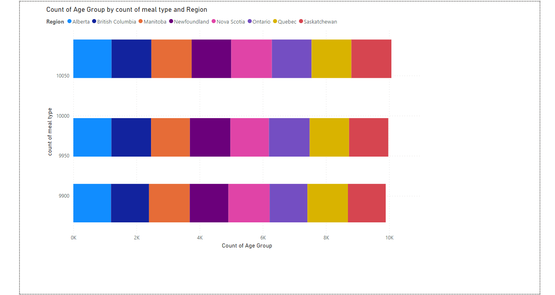

* **Pie Charts**: Pie charts were used to show the distribution of cuisine preferences, illustrating that Mexican cuisine is the top choice among all age groups.

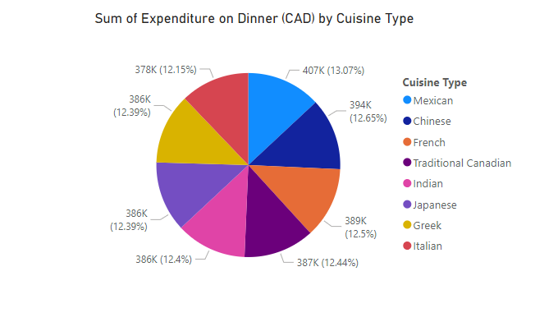

* **Line Charts**: Line charts were used to track expenditure trends across income groups and age groups, showing how spending changes with age and income levels.

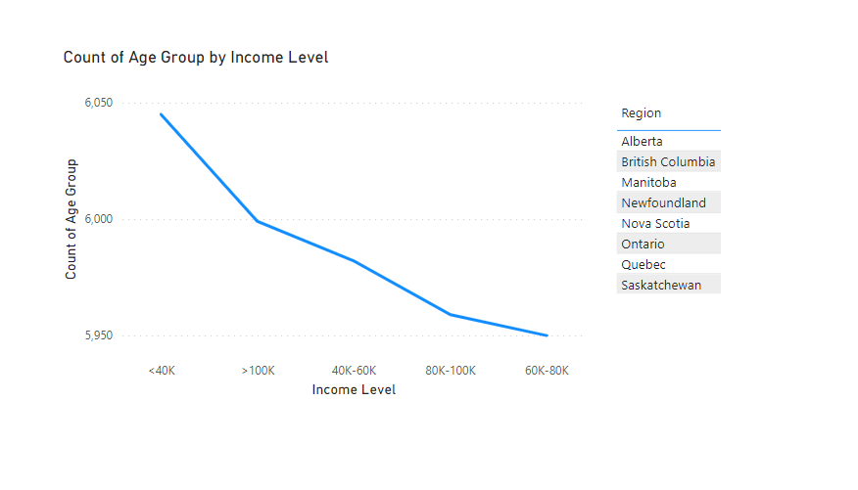

**7. Conclusion**

The analysis of Canadian dinner trends reveals significant insights into how age, income, and regional factors influence dining preferences. Younger individuals are more likely to choose takeout, while older groups prefer home-cooked meals. High-income individuals dine out more frequently and spend more per meal. Mexican cuisine is the most popular, while Italian cuisine is the least favored. These insights are invaluable for businesses in the food industry looking to tailor their offerings to consumer preferences.